Signs of Strength

Use these things for a little clickable slide box like the [U of R “Supporting Our Students” box](http://giving.richmond.edu/challenge/).

**Dr. Bill Shear receives NSF Grant**



*Your gift enables our students to learn from an internationally known taxonomist.*Read more about Dr. Shear’s Story.  
Link to: <http://www.hsc.edu/News/News-Articles/Shear.html>

**Dr. Alex Werth publishes research**

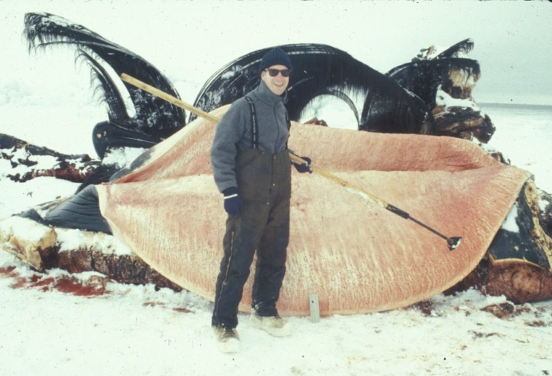

*Your gift supports expert faculty who are committed to their students.*Read more about Dr. Werth’s Story.  
Link to: <http://www.hsc.edu/News/News-Articles/Werth.html>

**H-SC wins VFIC Ethics Bowl**

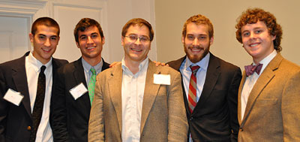

*Your gift supports our championship debate team.*Read more about the Ethics Bowl team.  
<http://www.hsc.edu/News/News-Articles/Ethics.html>